Setiap toko yang melakukan pembelian barang tidak pasti semua barang yang dipesan keadaannya semuanya sempurna. Oleh karena itu barang-barang tersebut harus dikembalikan kepada pihak supplier barang tersebut. Oleh karena itu aplikasi ini akan mencover hal ini dan kita akan membuat form retur pembelian barang. Form retur pembelian ini bertujuan untuk mencatat retur barang yang terjadi. Untuk membuat from retur pembelian ini yang kita butuhkan adalah :

|  |  |  |
| --- | --- | --- |
| **Object** | **Properties** | **Setting** |
| **Form** | Name | FrmBeliBarang |
|  | BorderStyle | 0-None |
|  | BackColor | &H00FFC0C0& |
|  | StartUpPosition | 2-CenterScreen |
| **Label** | Name | Label1 |
|  | Font | Calibri |
|  | ForeColor | &H8000000D& |
|  | Caption | Form Retur Pembelian |
|  | Name | Label2 |
|  | Font | Calibri |
|  | ForeColor | &H8000000D& |
|  | Caption | No Kwitansi |
|  | Name | Label3 |
|  | Font | Calibri |
|  | ForeColor | &H8000000D& |
|  | Caption | Supplier |
|  | Name | Label4 |
|  | Font | Calibri |
|  | ForeColor | &H8000000D& |
|  | Caption | Tanggal Transaksi |
|  | Name | Label5 |
|  | Font | Calibri |
|  | ForeColor | &H8000000D& |
|  | Caption | Tanggal Kirim |
|  | Name | Label6 |
|  | Font | Calibri |
|  | ForeColor | &H8000000D& |
|  | Caption | Penerima |
|  | Name | Label7 |
|  | Font | Calibri |
|  | ForeColor | &H8000000D& |
|  | Caption | Nama Barang |
|  | Name | Label8 |
|  | Font | Calibri |
|  | ForeColor | &H8000000D& |
|  | Caption | Alasan |
|  | Name | Label9 |
|  | Font | Calibri |
|  | ForeColor | &H8000000D& |
|  | Caption | Jumlah Barang Retur |
| **Textbox** | Name | TxtSupplier |
|  | Appearance | 0-Flat |
|  | Height | 330 |
|  | Name | TxtPenerima |
|  | Appearance | 0-Flat |
|  | Height | 330 |
|  | Name | TxtAlasan |
|  | Appearance | 0-Flat |
|  | Height | 330 |
| **TDBDate** | Name | TxtTgl |
|  | DisplyFormat | dd mmmm yyy |
|  | ButtonVisible | 1-True |
|  | Height | 330 |
|  | Name | TxtTglKirim |
|  | DisplyFormat | dd mmmm yyy |
|  | ButtonVisible | 1-True |
|  | Height | 330 |
| **SSOleDBCombo** | Name | CmbBarang |
|  | Height | 330 |
|  | BackColorOdd | &H00FFC0C0& |
|  | Name | CmbBarang |
|  | Height | 330 |
|  | BackColorOdd | &H00FFC0C0& |
|  | Name | CmbTransaksi |
|  | Height | 330 |
|  | BackColorOdd | &H00FFC0C0& |
|  | Name | CmbBarang |
|  | Height | 330 |
|  | BackColorOdd | &H00FFC0C0& |
| **TDBNumber** | Name | TxtJumlah |
|  | Height | 330 |
|  | appearance | 0-Flat |
|  | DisplayFormat | ###,###,###,##0.00;(###,###,###,##0.00) |
|  | Format | ###,###,###,##0.00 |
| **VBButton** | Name | CmdSave |
|  | ButtonType | 4-Mac |
|  | Caption | &Save |
|  | Name | CmdCancel |
|  | ButtonType | 4-Mac |
|  | Caption | &Cancel |
|  | Name | CmdInput |
|  | ButtonType | 4-Mac |
|  | Caption | &Cari |
|  | Name | vbButton1 |
|  | ButtonType | 3-WindowsXP |
|  | Caption | - |
|  | BackColor | &H00FFC0C0& |
|  | Name | vbButton2 |
|  | ButtonType | 3-WindowsXP |
|  | Caption | X |
|  | BackColor | &H00FFC0C0& |
| **TDBGrid** | Name | Grid |
|  | DeadAreaColor | &H00FFC0C0& |
|  | ColumnFooter | False |
|  | MarqueeStyle | 2-HighlightCell |
| **Adodc** | Name | AdoBarang |
|  | Visible | False |
|  | Name | AdoTransaksi |
|  | Visible | False |

Tampilan design form retur pembelian :

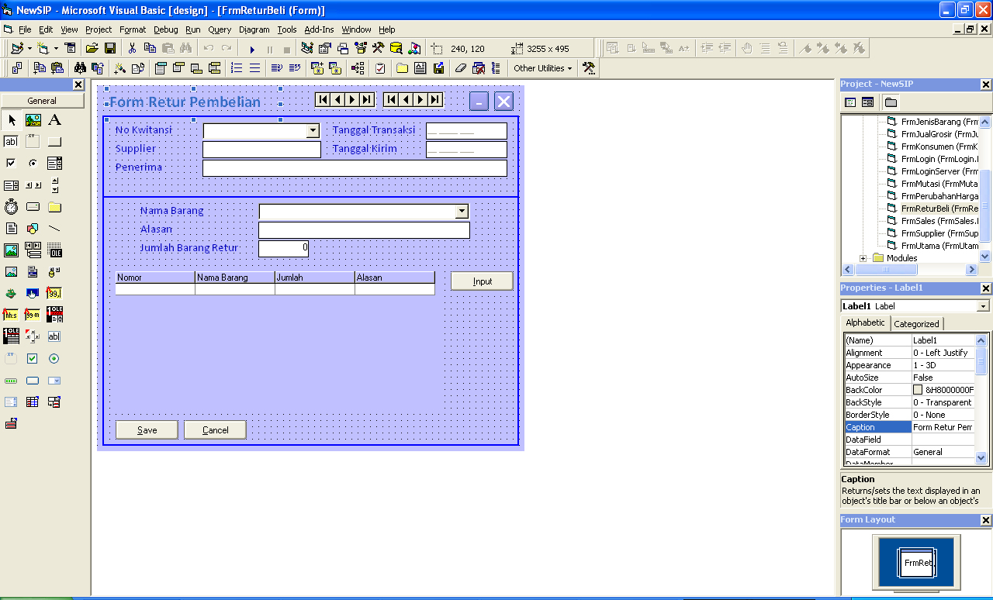

Tampilan form retur pembelian saat dijalankan :

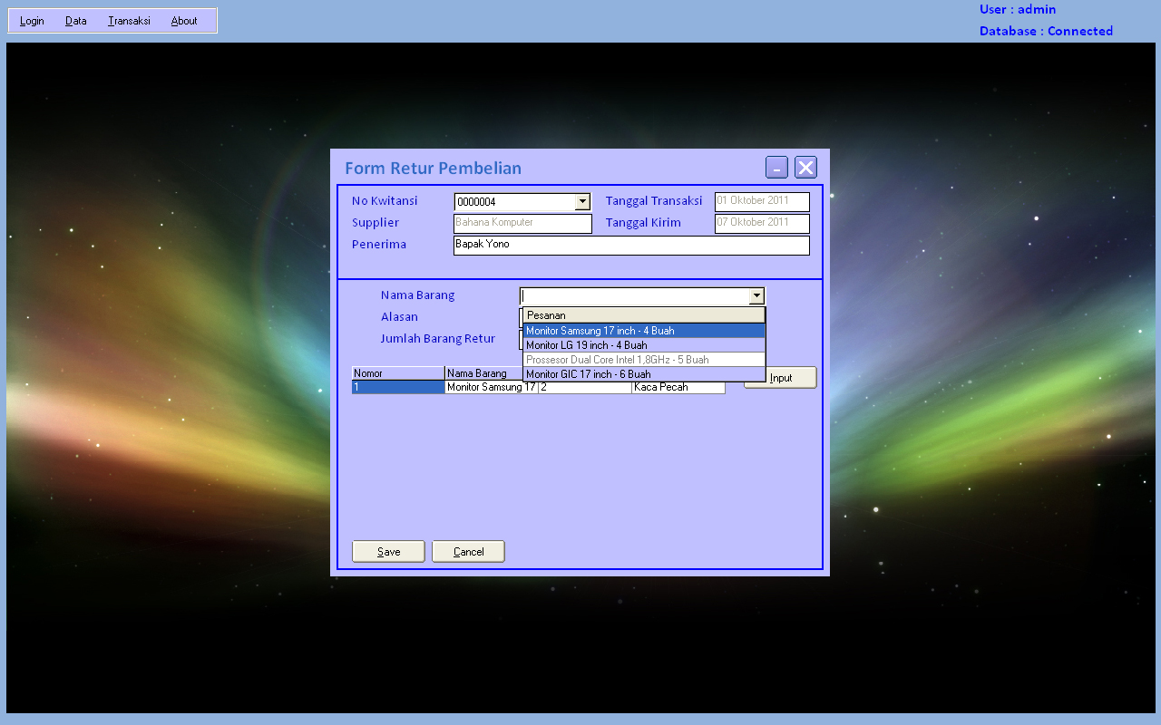

Source code program form retur pembelian :

Dim RsTemp3 As New ADODB.Recordset

Dim Keterangan1 As Integer

Private Sub CmbBarang_DropDown()

AdoBarang.RecordSource = ""

SQL = "SELECT DtlBeliBarang.KodeBarang, Barang.NamaBarang, DtlBeliBarang.Jumlah, " & _

" Barang.NamaBarang + ' - ' + DtlBeliBarang.Jumlah + ' ' + Barang.Satuan AS Pesanan " & _

" FROM Barang INNER JOIN " & _

" DtlBeliBarang ON Barang.KodeBarang = DtlBeliBarang.KodeBarang where " & _

" kodeTransaksi='" & Trim(CmbTransaksi) & "'"

Set RSFind = DbCon.Execute(SQL)

If RSFind.BOF Then Exit Sub

AdoBarang.RecordSource = SQL

AdoBarang.Refresh

With CmbBarang

.DataSourceList = AdoBarang

.DataFieldList = "Pesanan"

.Columns(0).Visible = False

.Columns(1).Visible = False

.Columns(2).Visible = False

.Columns(3).Width = 4000

End With

End Sub

Private Sub CmbBarang_GotFocus()

If Trim(CmbTransaksi) = "" Or Not CmbTransaksi.IsItemInList Then

MsgBox "Transaksi Belum Dipilih"

CmbTransaksi.SetFocus

Exit Sub

End If

End Sub

Private Sub CmbTransaksi_Click()

TxtSupplier = Trim(CmbTransaksi.Columns(2).Text)

TxtTgl = CmbTransaksi.Columns(1).Value

TxtTglKirim = CmbTransaksi.Columns(3).Value

CmbBarang = ""

CmbBarang.SetFocus

End Sub

Private Sub CmbTransaksi_DropDown()

AdoTransaksi.RecordSource = ""

SQL = "SELECT * from BeliBarang"

Set RSFind = DbCon.Execute(SQL)

If RSFind.BOF Then Exit Sub

AdoTransaksi.RecordSource = SQL

AdoTransaksi.Refresh

With CmbTransaksi

.DataSourceList = AdoTransaksi

.DataFieldList = "KodeTransaksi"

.Columns(3).Visible = False

.Columns(2).Visible = False

.Columns(1).Visible = False

.Columns(3).Width = 4000

End With

End Sub

Private Sub CmdCancel_Click()

Form_Load

End Sub

Private Sub CmdInput_Click()

If Trim(CmbBarang) = "" Or Not CmbBarang.IsItemInList Then

MsgBox "Barang Belum Ada"

CmbBarang.SetFocus

Exit Sub

ElseIf Trim(TxtAlasan) = "" Then

MsgBox "Alasan Belum Ada"

TxtAlasan.SetFocus

Exit Sub

ElseIf TxtJumlah = 0 Then

MsgBox "Jumlah Belum Ada"

TxtJumlah.SetFocus

Exit Sub

End If

SQL = "Select jumlah from dtlbelibarang where kodeTransaksi='" & Trim(CmbTransaksi) & _

"' and kodebarang='" & Trim(CmbBarang.Columns(0).Text) & "'"

Set RSFind = DbCon.Execute(SQL)

If Val(RSFind!Jumlah) < TxtJumlah Then

MsgBox "Jumlah Tidak Sesuai Dengan Pesanan"

TxtJumlah = 0

TxtJumlah.SetFocus

Exit Sub

End If

RsTemp3.Find "KodeBarang='" & Trim(CmbBarang.Columns(0).Text) & "'", , adSearchForward, 1

If RsTemp3.EOF Then

With RsTemp3

.AddNew

!NoKet = .RecordCount

!KodeBarang = Trim(CmbBarang.Columns(0).Text)

!namaBarang = Trim(CmbBarang.Columns(1).Text)

!Jumlah = TxtJumlah

!Alasan = Trim(TxtAlasan)

.Update

Grid.Refresh

CmbBarang = ""

TxtAlasan = ""

TxtJumlah = 0

CmbBarang.SetFocus

End With

Else

MsgBox "Barang Sudah Dinputkan"

CmbBarang = ""

TxtAlasan = ""

TxtJumlah = 0

CmbBarang.SetFocus

Exit Sub

End If

End Sub

Private Sub CmdSave_Click()

If RsTemp3.RecordCount = 0 Then

MsgBox "Tidak Ada Daftar Barang Retur"

Exit Sub

Else

SQL = "insert into ReturBeli values('" & Trim(CmbTransaksi) & "','" & FormatTgl(Date) & "','" & _

Trim(TxtPenerima) & "')"

DbCon.Execute SQL

RsTemp3.MoveFirst

While Not RsTemp3.EOF

With RsTemp3

SQL = "insert into dtlReturBeli values('" & Trim(CmbTransaksi) & "','" & FormatTgl(Date) & "','" & _

Trim(!NoKet) & "','" & Trim(!KodeBarang) & "','" & !Jumlah & "','" & !Alasan & "')"

DbCon.Execute SQL

End With

RsTemp3.MoveNext

Wend

End If

MsgBox "Data Saved"

Form_Load

End Sub

Private Sub Form_Load()

AdoTransaksi.ConnectionString = ConDB

AdoBarang.ConnectionString = ConDB

Bersih

With RsTemp3

If .State Then .Close

.Fields.Append "NoKet", adInteger, 4

.Fields.Append "KodeBarang", adVarChar, 50

.Fields.Append "NamaBarang", adVarChar, 50

.Fields.Append "Jumlah", adInteger, 4

.Fields.Append "Alasan", adVarChar, 100

.Open

Set Grid.DataSource = RsTemp3

Grid.Refresh

End With

End Sub

Sub Bersih()

CmbTransaksi = ""

TxtSupplier = ""

TxtTgl = Null

TxtTglKirim = Null

CmbBarang = ""

TxtAlasan = ""

TxtPenerima = ""

End Sub

Private Sub Grid_Click()

Keterangan1 = Val(Grid.Columns(0).Text)

End Sub

Private Sub Grid_KeyDown(KeyCode As Integer, Shift As Integer)

If KeyCode = 46 Then

If Keterangan1 = 0 Then

MsgBox "Klik Salah Satu Item Di Tabel"

Exit Sub

End If

RsTemp3.Find "noket='" & Keterangan1 & "'", , adSearchForward, 1

If Not RsTemp3.EOF Then

MsgBox RsTemp3!NoKet & " Dibatalkan"

RsTemp3.Delete

End If

Keterangan1 = Keterangan1 + 1

RsTemp3.Find "noket='" & Keterangan1 & "'", , adSearchForward, 1

While Not RsTemp3.EOF

With RsTemp3

.Clone

!NoKet = !NoKet - 1

.Update

End With

RsTemp3.MoveNext

Wend

Grid.Refresh

End If

End Sub

Private Sub Grid_RowColChange(LastRow As Variant, ByVal LastCol As Integer)

Keterangan1 = Val(Grid.Columns(0).Text)

End Sub

Private Sub vbButton1_Click()

Me.WindowState = vbMinimized

End Sub

Private Sub vbButton2_Click()

Unload Me

End Sub